Chapter 4

Methodology
3.2 Model Architecture Selection
Selecting an appropriate CNN architecture is essential for developing an image classification system that can operate efficiently on resource-constrained edge devices. While many deep learning models achieve excellent recognition accuracy, their computational complexity often limits their use in real-time mobile applications. Therefore, this study emphasizes both predictive performance and deployment efficiency rather than accuracy alone.
To identify the most suitable architecture for offline Android deployment, five transfer learning-based CNN models were selected for comparison:
- MobileNetV2
- MobileNetV3-Small
- EfficientNetV2B0
- DenseNet121
- NASNetMobile
These architectures represent different lightweight CNN design approaches and are fully compatible with TensorFlow Lite. Each model also provides pretrained ImageNet weights, making them well suited for transfer learning.
Instead of training from scratch, all models were initialized with pretrained ImageNet weights to leverage previously learned low-level visual features such as edges, textures, and color patterns. This approach reduces training time, accelerates convergence, and improves generalization, particularly when working with a relatively small dataset.
To ensure a fair comparison, every architecture followed the same transfer learning strategy. The original classification layer was removed (include_top=False), and the pretrained backbone remained frozen during the initial training stage while only the newly added classifier was optimized. This preserves the learned feature representations and minimizes overfitting.
An identical classification head was attached to each backbone, consisting of:
- Global Average Pooling (GAP)
- Dropout (0.30)
- Dense layer (128 neurons, ReLU)
- Softmax output layer (10 classes)
The GAP layer reduces feature dimensionality with fewer trainable parameters than conventional fully connected layers, while Dropout improves model generalization by reducing overfitting. Finally, the Softmax layer generates the probability distribution for the ten indigenous Bangladeshi mango varieties, ensuring a consistent evaluation across all architectures.

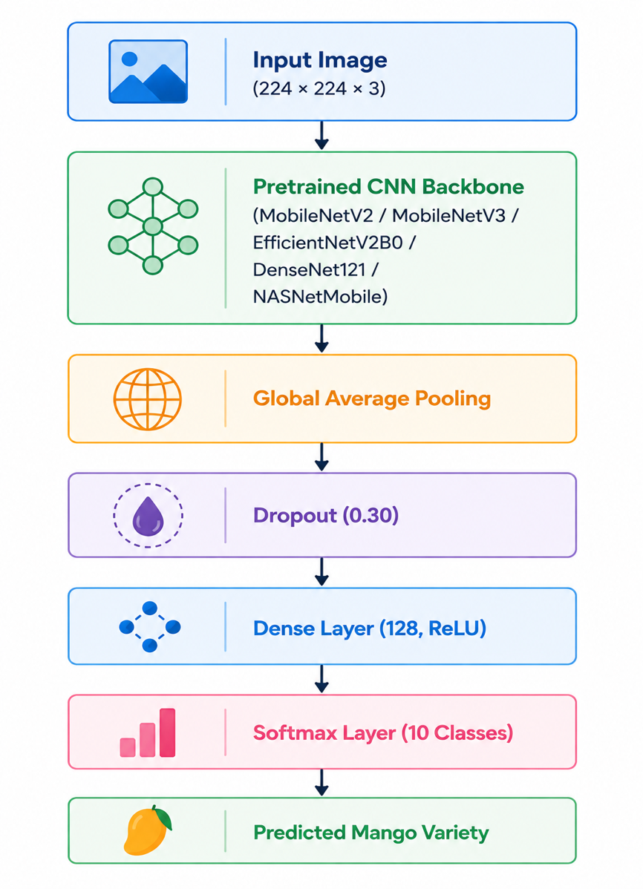
The architecture of the classifier can be summarized as follows:

Mathematical Representation
Let
$$(I∈R^{224×224×3})$$
represent an input RGB image.
The pretrained CNN backbone extracts feature representations
$$[F=f_{θ}\left(I\right)]$$
where
- “I” is the resized input image,
- $(f_{θ})$ denotes the convolutional feature extractor,
- “F” represents the extracted feature map.
Global Average Pooling converts the feature map into a feature vector
$$[z=GAP\left(F\right)]$$
which is then passed through the dense classifier
$$[h=ReLU\left(W_{1}z+b_{1}\right)]$$
Finally, the Softmax function computes the posterior probability of each mango variety
$$[P\left(y=i | I\right)=\frac{e^{h_{i}}}{\sum_{j=1}^{10}{e^{h_{j}}}]}$$
where
- $(P\left(y=i | I\right))$ represents the probability that the input image belongs to class \(i\),
- $(i=1,…,10).$
The predicted class is determined by
$$[\hat{y}=\arg{\max_{i}{P}}\left(y=i | I\right)]$$
Selection Criteria
Each CNN architecture was evaluated according to the following criteria:
- Classification Accuracy
- Precision
- Recall
- Weighted F1-score
- Model Storage Size (MB)
- Inference Latency (ms)
- Deployment Compatibility with TensorFlow Lite
Unlike conventional image classification studies that emphasize accuracy alone, these criteria collectively assess both predictive capability and practical deployment feasibility. This comprehensive evaluation enables identification of the most suitable architecture for real-time Edge AI applications.
Table 3.4 Selection Criteria for CNN Benchmarking
Evaluation Criterion | Purpose
Accuracy | Overall classification performance
Precision | Reliability of positive predictions
Recall | Ability to correctly identify true classes
Weighted F1-score | Balanced evaluation considering class distribution
Model Size | Storage requirement for mobile deployment
Inference Latency | Real-time execution capability
TFLite Compatibility | Suitability for Android edge deployment

Architecture Overview
Unlike traditional CNNs that repeatedly increase feature dimensions through standard convolution operations, MobileNetV2 adopts a more computationally efficient design. Each building block consists of three consecutive operations:
- Expansion Layer
- Depthwise Convolution
- Linear Projection (Bottleneck)
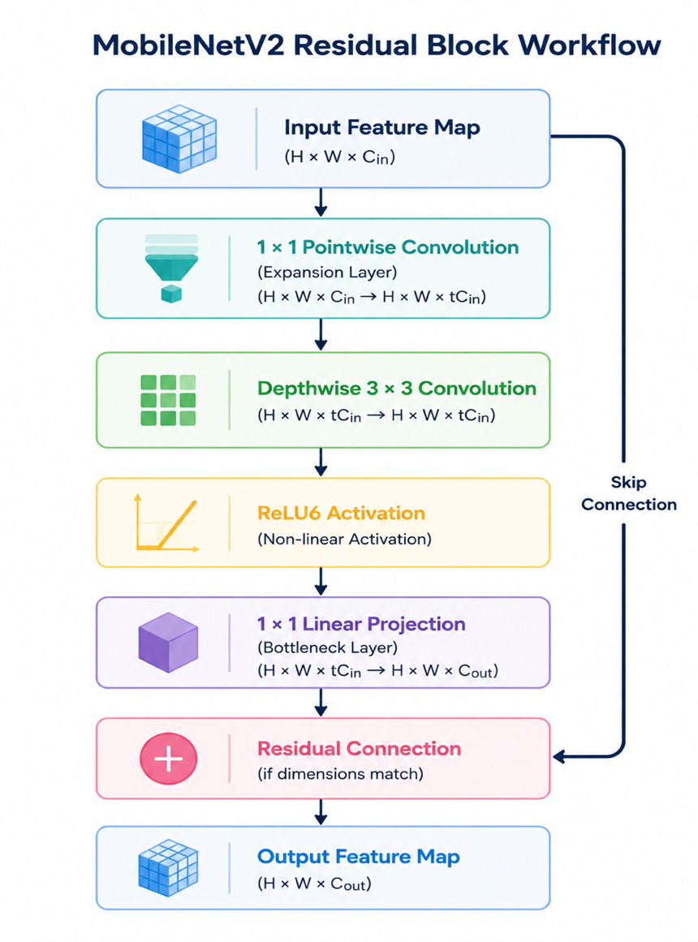
The overall workflow of a MobileNetV2 residual block is illustrated below.

Depthwise Separable Convolution
The computational efficiency of MobileNetV2 primarily originates from depthwise separable convolution, which replaces computationally expensive standard convolution operations.
A standard convolution simultaneously performs spatial filtering and channel combination using
$$[D_{K}^{2}×M×N]$$
filters, where
- D_{k} = kernel size,
- M = number of input channels,
- N = number of output channels.
The computational complexity is therefore
$$[Cost_{Standard}=D_{K}^{2}×M×N×D_{F}^{2}]$$
where D_{k} denotes the spatial resolution of the feature map.
MobileNetV2 decomposes this operation into two independent stages:
Depthwise Convolution
Each input channel is filtered independently using a single convolution kernel.
The computational cost becomes
$$[D_{K}^{2}×M×D_{F}^{2}]$$
Pointwise Convolution
A subsequent $(1 ×1)$ convolution combines information across channels.
Its computational cost is
$$[M×N×D_{F}^{2}]$$
Therefore, the total computational complexity becomes
$$[Cost_{Depthwise}=D_{K}^{2}MD_{F}^{2}+MND_{F}^{2}]$$
which is considerably smaller than standard convolution.
For typical CNN configurations, depthwise separable convolution reduces computation by nearly 8–9 times, enabling efficient execution on mobile processors without substantially compromising feature extraction capability [1].

3.2.2 MobileNetV3-Small
MobileNetV3-Small is the primary deep learning architecture adopted in this research for deployment on mobile edge devices. Developed by Howard et al. in 2019, MobileNetV3 represents the third generation of the MobileNet family and was specifically designed to maximize the trade-off between classification accuracy and computational efficiency for resource-constrained hardware [1]. Unlike its predecessors, MobileNetV3 was developed using a combination of Neural Architecture Search (NAS) and NetAdapt, enabling the network architecture to be automatically optimized for both predictive performance and execution speed on mobile processors.

Architecture Overview
MobileNetV3-Small inherits the efficient depthwise separable convolution mechanism from previous MobileNet architectures while introducing several additional optimizations, including:
- Inverted Residual Blocks
- Depthwise Separable Convolution
- Squeeze-and-Excitation (SE) Attention Modules
- Hard-Swish (H-Swish) Activation Function
- Hardware-aware Neural Architecture Search (NAS)
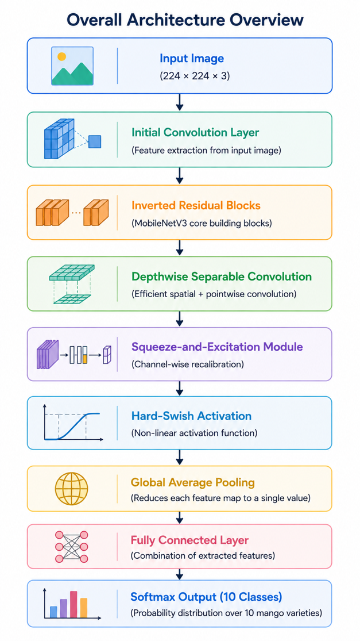
The overall architecture can be conceptually represented as follows.

Figure 3.5: Simplified architecture of MobileNetV3-Small used in this research.

Depthwise Separable Convolution
Similar to MobileNetV2, MobileNetV3 employs depthwise separable convolution to reduce computational complexity.
Instead of simultaneously learning spatial and channel relationships through standard convolution, the operation is divided into:
- Depthwise Convolution
- Pointwise Convolution
This decomposition substantially decreases the number of floating-point operations (FLOPs) while maintaining effective feature extraction.
The computational complexity becomes
$$[Cost_{DW}=D_{K}^{2}MD_{F}^{2}+MND_{F}^{2}]$$
where
- “D_{k”} denotes kernel size,
- “M” represents input channels,
- “N” represents output channels,
- “D_{k}” denotes feature map dimensions.
Compared with standard convolution, depthwise separable convolution dramatically reduces computational requirements, making MobileNetV3 highly suitable for mobile inference.

Inverted Residual Block
MobileNetV3 retains the Inverted Residual Block introduced in MobileNetV2.
Rather than connecting expanded feature representations, shortcut connections operate between compact bottleneck layers.
The residual mapping is defined as
$$[y=x+F\left(x\right)]$$
where
- “X” represents the bottleneck input,
- “F(x)” denotes the transformed feature representation.
This design improves gradient propagation while minimizing memory consumption.

Squeeze-and-Excitation Attention Module
One of the most important improvements introduced in MobileNetV3 is the incorporation of the Squeeze-and-Excitation (SE) module.
Traditional convolution layers treat every feature channel equally. However, not all feature channels contribute equally to image recognition. The SE module enables the network to learn which channels are most informative by assigning adaptive importance weights during training.
The SE module operates in three stages:
- Squeeze
Global Average Pooling compresses spatial information into a channel descriptor.
$$[z_{c}=\frac{1}{H×W}\sum_{i=1}^{H}{\sum_{j=1}^{W}{x_{c}\left(i,j\right)]}}$$
where
- H and W denote feature map height and width,
- $(x_{c}\left(i,j\right))$ is the activation of channel c.
- Excitation
The channel descriptor passes through two fully connected layers to generate channel-wise attention weights.
$$[s=σ\left(W_{2}δ\left(W_{1}z\right)\right)]$$
where
- $(δ\left(⋅\right))$ is the ReLU activation,
- $(σ\left(⋅\right))$ is the Sigmoid function.
- Feature Recalibration
Each feature channel is multiplied by its corresponding attention weight.
$$[\hat{x_{c}}=s_{c}x_{c}]$$
This mechanism enables MobileNetV3 to emphasize discriminative visual features while suppressing less informative responses, improving classification performance for fine-grained image recognition tasks such as mango variety classification.

3.2.3 EfficientNetV2B0
EfficientNetV2B0 is a modern convolutional neural network architecture designed to achieve high classification accuracy while maintaining improved computational efficiency compared with earlier deep learning models. Proposed by Tan and Le in 2021, EfficientNetV2 was developed to address two major limitations of the original EfficientNet family: slow training speed and high computational cost associated with large-scale image classification tasks [1]. By introducing optimized convolutional blocks and an improved scaling strategy, EfficientNetV2 achieves faster training, enhanced feature extraction, and competitive classification performance across a wide range of computer vision applications.

Architecture Overview
EfficientNetV2B0 retains the fundamental philosophy of the EfficientNet family while incorporating several architectural improvements that accelerate training and improve computational efficiency. The network consists of a sequence of convolutional blocks that progressively learn increasingly abstract visual representations from the input image.
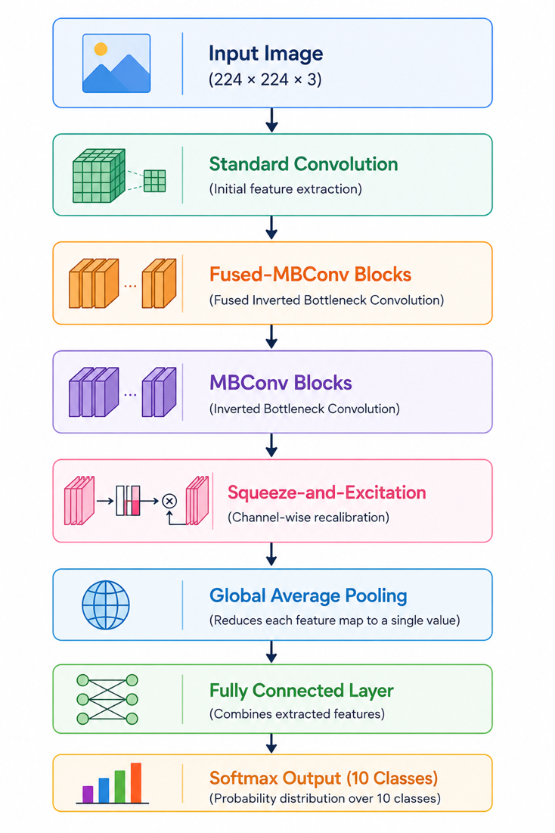
The simplified architecture is illustrated below.

Figure 3.6: Simplified architecture of EfficientNetV2B0 used in this research.

Fused-MBConv Block
One of the most significant innovations introduced in EfficientNetV2 is the Fused Mobile Inverted Bottleneck Convolution (Fused-MBConv).
In the original MBConv block, feature extraction consists of:
- Expansion Layer
- Depthwise Convolution
- Projection Layer
Although computationally efficient during inference, this structure introduces considerable memory access overhead during training.
To overcome this limitation, EfficientNetV2 replaces the early MBConv blocks with Fused-MBConv layers, where the expansion and depthwise convolution are merged into a single standard convolution operation.
This modification improves training efficiency while maintaining strong feature extraction capability.

MBConv Block
In deeper stages of the network, EfficientNetV2 continues to employ the Mobile Inverted Bottleneck Convolution (MBConv) introduced by the EfficientNet architecture.
The MBConv block consists of:
- Pointwise Expansion
- Depthwise Convolution
- Squeeze-and-Excitation Module
- Pointwise Projection
Mathematically,
$$[F\left(x\right)=PW\left(DW\left(PW\left(x\right)\right)\right)]$$
where
- “PW” denotes pointwise convolution,
- “DW” represents depthwise convolution,
- “F(x)” is the transformed feature representation.
Residual connections are applied whenever the input and output dimensions are identical.

Compound Scaling Strategy
Unlike conventional CNNs that increase only network depth or width, EfficientNetV2 adopts a compound scaling strategy that simultaneously scales multiple architectural dimensions.
The network balances:
- Depth
- Width
- Input Resolution
using scaling coefficients that maximize recognition performance under computational constraints.
The scaling process is represented as
$$[Depth=α^{ϕ}]$$
$$[Width=β^{ϕ}]$$
$$[Resolution=γ^{ϕ}]$$
subject to
$$[α⋅β^{2}⋅γ^{2}≈2]$$
where
- $\left(ϕ\right)$ denotes the compound scaling coefficient,
- $(α,β,γ)$ are constants determined during architecture optimization.
This balanced scaling strategy allows EfficientNetV2 to achieve high recognition accuracy without excessively increasing computational complexity.

3.2.4 NASNetMobile
NASNetMobile is a lightweight convolutional neural network architecture developed to achieve high classification performance while maintaining computational efficiency for mobile and embedded devices. Unlike conventional CNN architectures that are manually designed by researchers, NASNet (Neural Architecture Search Network) was automatically generated using Neural Architecture Search (NAS), an Artificial Intelligence-based optimization technique that explores thousands of possible network configurations to identify the architecture that provides the best balance between predictive accuracy and computational cost [1]. This automated design methodology enables NASNetMobile to achieve competitive recognition performance while reducing the need for manual architecture engineering.

Architecture Overview
The distinguishing feature of NASNetMobile is that its architecture was not manually constructed but automatically discovered through a reinforcement learning-based Neural Architecture Search process. Instead of designing every convolutional layer individually, NAS learns two reusable computational building blocks known as the Normal Cell and the Reduction Cell. These cells are repeatedly stacked to construct the complete neural network.
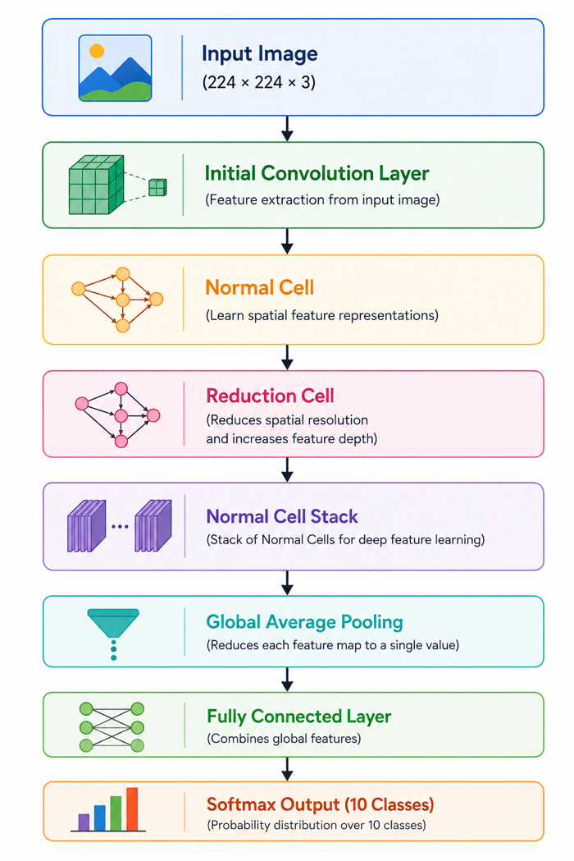
The simplified architecture is illustrated below.

Normal Cell
The Normal Cell is responsible for extracting high-level visual features while preserving the spatial dimensions of the input feature map. It consists of multiple parallel computational branches that perform different convolutional operations simultaneously. The outputs from these branches are combined to generate a richer feature representation.
The Normal Cell enables the network to learn diverse visual characteristics such as:
- shape,
- texture,
- edges,
- color patterns,
- fine morphological details.
Since the spatial resolution remains unchanged, the Normal Cell focuses primarily on improving feature representation without reducing image size.

Neural Architecture Search (NAS)
The most important contribution of NASNetMobile is its automated architecture generation process.
Unlike manually engineered networks, Neural Architecture Search formulates architecture design as an optimization problem.
Given an architecture search space
$$[A=\{a_{1},a_{2},…,a_{n}\}]$$
the search algorithm attempts to identify
$$[a^{*}=\arg{\max_{a∈A}{P}}erformance\left(a\right)]$$
where
- $(A)$ denotes the candidate architecture space,
- $(Performance\left(a\right))$ represents the validation accuracy of architecture \(a\),
- $(a^{*})$ is the optimal architecture selected by the search process.
The search controller is typically implemented using reinforcement learning, where candidate architectures are evaluated, rewarded according to their performance, and progressively refined until an optimal architecture is obtained.
This automated design strategy enables NASNetMobile to achieve strong predictive performance without relying entirely on manually engineered architectural decisions.

3.2.5 DenseNet121
DenseNet121 is a deep convolutional neural network architecture designed to improve feature propagation, encourage feature reuse, and alleviate the vanishing gradient problem commonly encountered in very deep neural networks. Proposed by Huang et al. in 2017, DenseNet (Densely Connected Convolutional Network) introduced a novel connectivity pattern in which every layer is directly connected to all subsequent layers within a dense block [1]. Unlike conventional CNN architectures that pass information only to the immediately following layer, DenseNet establishes direct feature connections between all preceding and succeeding layers. This dense connectivity enables efficient information flow throughout the network while improving learning efficiency and reducing redundant feature extraction.

Architecture Overview
The fundamental concept of DenseNet121 is the Dense Block, where each layer receives feature maps generated by every preceding layer. Rather than learning entirely new representations at each layer, DenseNet continuously reuses previously extracted features, allowing the network to preserve both low-level and high-level visual information throughout the learning process.
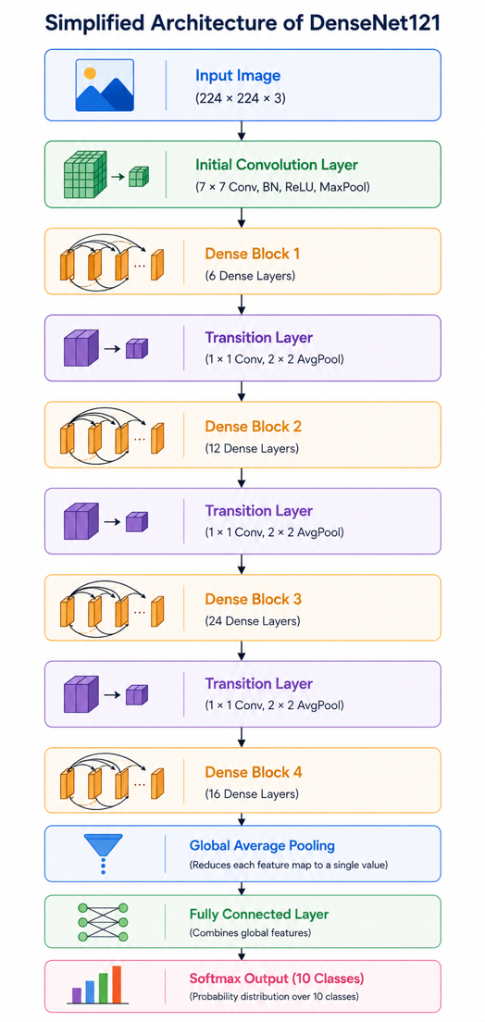
The simplified architecture of DenseNet121 is illustrated below.

Dense Connectivity
Unlike conventional convolutional neural networks where each layer receives input only from its immediate predecessor, DenseNet introduces direct feature propagation across all layers.
For the $(l^{th})$ layer,
$$[x_{l}=H_{l}\left(\left[x_{0},x_{1},…,x_{l-1}\right]\right)]$$
where
- $(x_{l})$ denotes the output of the$(l^{th})$layer,
- $(H_{l}\left(⋅\right))$ represents the sequence of Batch Normalization, ReLU activation, and convolution,
- $(\left[ \right])$denotes feature map concatenation.
Instead of summing feature maps as performed in ResNet, DenseNet concatenates all previous feature representations.
This dense connectivity offers several important advantages:
- improved gradient propagation,
- efficient feature reuse,
- stronger information preservation,
- reduced feature redundancy,
- improved learning stability.
Consequently, DenseNet121 is capable of learning highly discriminative representations even when trained on relatively small datasets.

Transition Layer
Without additional processing, repeated feature concatenation would continuously increase the number of feature maps.
To control computational complexity, DenseNet introduces Transition Layers between consecutive Dense Blocks.
Each Transition Layer consists of:
- Batch Normalization,
- $(1 ×1)$ convolution,
- Average Pooling.
These operations reduce both the number of feature channels and the spatial dimensions of the feature maps, thereby limiting memory consumption while preserving the most informative features.

3.3 Dynamic Preprocessing Implementation
Deep learning models pretrained on large-scale datasets such as ImageNet are trained using architecture-specific input preprocessing techniques. These preprocessing operations transform raw pixel values into numerical representations that match the data distribution observed during the original pretraining process. Consequently, different convolutional neural network (CNN) architectures expect different input formats before inference. Applying an inappropriate preprocessing function may introduce a distribution mismatch between the training data and the pretrained feature extractor, resulting in degraded feature learning, slower convergence, and reduced classification accuracy [1].

Architecture-Specific Preprocessing Functions
The preprocessing functions used in this research are summarized in Table 3.5.
Table 3.5 Architecture-Specific Preprocessing Functions
CNN Architecture | TensorFlow Preprocessing Function
MobileNetV2 | mobilenet_v2.preprocess_input()
MobileNetV3-Small | mobilenet_v3.preprocess_input()
EfficientNetV2B0 | efficientnet_v2.preprocess_input()
DenseNet121 | densenet.preprocess_input()
NASNetMobile | nasnet.preprocess_input()
Each preprocessing function performs the transformations required by its corresponding pretrained architecture. Because these implementations are provided by TensorFlow, they preserve compatibility with the ImageNet feature representations learned during pretraining.

Dynamic Preprocessing Workflow
Instead of maintaining separate training scripts for each CNN architecture, a unified preprocessing framework was implemented. During execution, the selected CNN architecture determines which preprocessing function is passed to the data generator.
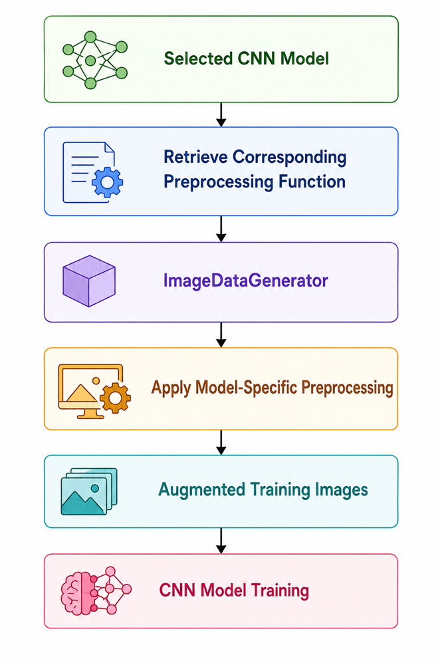
The workflow is illustrated in Figure 3.9.

Implementation Strategy
The dynamic preprocessing mechanism was implemented by maintaining a preprocessing function associated with each CNN architecture inside the model configuration module. During training, the selected preprocessing function is passed directly to TensorFlow's ImageDataGenerator, which automatically applies the appropriate transformation before generating each batch.
Conceptually, the workflow can be represented as
This modular implementation eliminates the need to manually modify preprocessing code whenever a different CNN architecture is evaluated. Consequently, all benchmark experiments can be executed using the same training pipeline while preserving model-specific preprocessing behavior.

Integration with Data Augmentation
An important characteristic of the proposed framework is that dynamic preprocessing is fully integrated with the online data augmentation pipeline described in Section 3.1.2.
During training, each image undergoes the following sequence of operations:
- Image loading
- Image resizing (224 × 224 pixels)
- Architecture-specific preprocessing
- Online data augmentation
- Batch generation
- CNN training
This integrated workflow ensures that every augmented image also satisfies the preprocessing requirements of its corresponding CNN architecture.

3.3.1 Architectural Input Disparities
One of the fundamental assumptions of transfer learning is that the input data presented during fine-tuning should follow the same statistical distribution as the data used during the original pretraining stage. Modern convolutional neural networks pretrained on the ImageNet dataset learn feature representations based on architecture-specific preprocessing procedures that transform raw pixel values into normalized numerical distributions. Consequently, different CNN architectures expect different input formats before performing feature extraction. Ignoring these architectural differences may introduce inconsistencies between the input data and the pretrained weights, ultimately reducing feature extraction quality and degrading classification performance [1].
Table 3.6 Architectural Input Preprocessing Requirements
CNN Architecture | Preprocessing Function | Purpose
MobileNetV2 | mobilenet_v2.preprocess_input() | Prepares images according to MobileNetV2 ImageNet training distribution
MobileNetV3-Small | mobilenet_v3.preprocess_input() | Matches MobileNetV3-Small pretrained input representation
EfficientNetV2B0 | efficientnet_v2.preprocess_input() | Applies EfficientNetV2-specific preprocessing
DenseNet121 | densenet.preprocess_input() | Preserves DenseNet ImageNet normalization scheme
NASNetMobile | nasnet.preprocess_input() | Produces NASNet-compatible input representation

3.3.2 Pipeline Design
To ensure a fair and reproducible comparison among multiple convolutional neural network (CNN) architectures, this research adopts a unified and modular training pipeline. Instead of developing separate workflows for each model, a single automated pipeline was designed to handle dataset preparation, architecture-specific preprocessing, model construction, training, evaluation, benchmarking, and model storage. This unified implementation minimizes manual intervention, reduces code redundancy, and guarantees that all evaluated models are trained under identical experimental conditions.

Overall Pipeline Architecture
The complete pipeline implemented in this research consists of seven major stages:
- Dataset Loading
- Image Preprocessing
- Data Augmentation
- Model Construction
- Model Training
- Performance Evaluation
- Model Export and Benchmarking
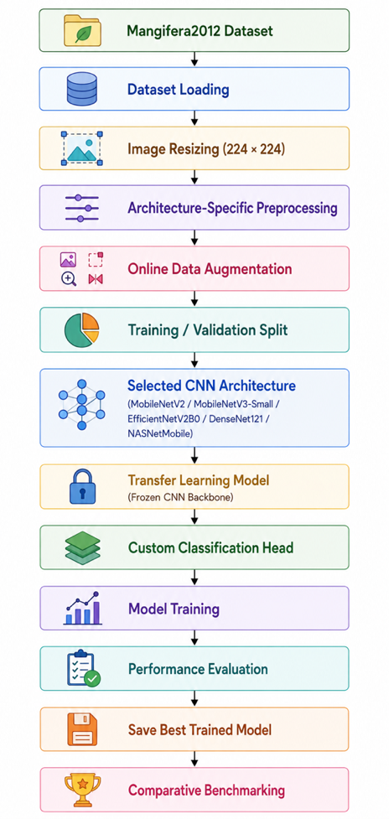
The overall workflow is illustrated in Figure 3.11.

Training Pipeline
Stage 1: Dataset Loading
The Mangifera2012 dataset is loaded directly from its class-wise directory structure, allowing TensorFlow to assign labels automatically based on folder names. This approach ensures consistent label encoding throughout the training process.
Stage 2: Image Preprocessing
Each image is resized to 224 × 224 pixels before applying the architecture-specific preprocessing function required by the corresponding ImageNet-pretrained CNN model.
Stage 3: Online Data Augmentation
To improve generalization, ImageDataGenerator performs online augmentation during training. Random transformations—including rotation, width and height shifts, shear, zoom, and horizontal flipping—generate new image variations in every epoch without increasing the dataset size.
Stage 4: Model Construction
Each CNN model is initialized with pretrained ImageNet weights. The original classification layer is removed, the convolutional backbone remains frozen, and a common classifier is added consisting of:
- Global Average Pooling (GAP)
- Dropout (0.30)
- Dense layer (128 neurons, ReLU)
- Softmax output layer (10 classes)
Using an identical classification head ensures a fair comparison among all architectures.
Stage 5: Model Training
Training is performed using the Adam optimizer with transfer learning. The process incorporates early stopping, best-weight restoration, and mini-batch optimization to improve convergence and reduce overfitting. Training automatically stops when validation performance no longer improves.
Stage 6: Performance Evaluation
The trained model is evaluated using multiple performance metrics, including accuracy, precision, recall, weighted F1-score, confusion matrix, and classification report, providing a comprehensive assessment of classification performance.
Stage 7: Model Storage and Benchmarking
After evaluation, the trained model is saved for future deployment. Additional benchmarking measures model size, inference latency, and deployment compatibility. Finally, the results from all five CNN architectures are compared to identify the most suitable model for Edge AI deployment.

Pipeline Automation
An important contribution of this research is the automation of the complete benchmarking process.
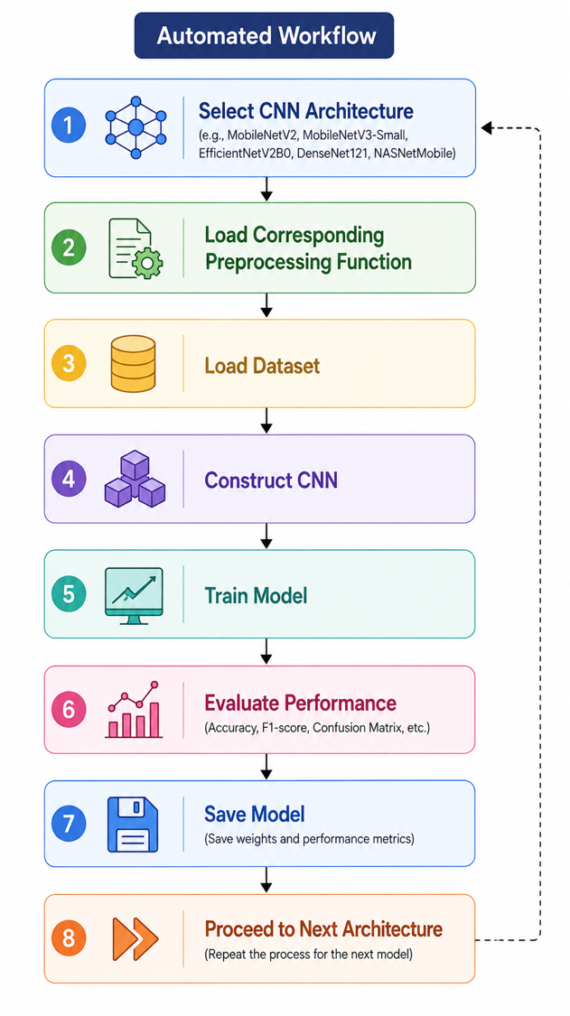
Rather than manually repeating the training procedure for each CNN architecture, the pipeline automatically performs the following sequence:

This automated workflow significantly improves experimental efficiency while eliminating inconsistencies caused by manual intervention.

3.4 Methodology Flowchart
This research follows a structured methodology that integrates dataset preparation, deep learning model development, comparative benchmarking, deployment-oriented optimization, and mobile application implementation into a unified Edge AI framework. Rather than focusing solely on model training, the proposed methodology encompasses the complete lifecycle of an intelligent image classification system, beginning with data preparation and ending with real-time offline deployment on Android smartphones.
The workflow was designed to ensure fairness, reproducibility, and deployment readiness. All evaluated convolutional neural network (CNN) architectures were trained under identical experimental settings using the same dataset, preprocessing pipeline, data augmentation strategy, optimizer configuration, and evaluation protocol. This standardized methodology ensures that differences in experimental performance are attributable to the inherent characteristics of the CNN architectures rather than inconsistencies in implementation.
The complete research methodology adopted in this study is illustrated in Figure 3.12.

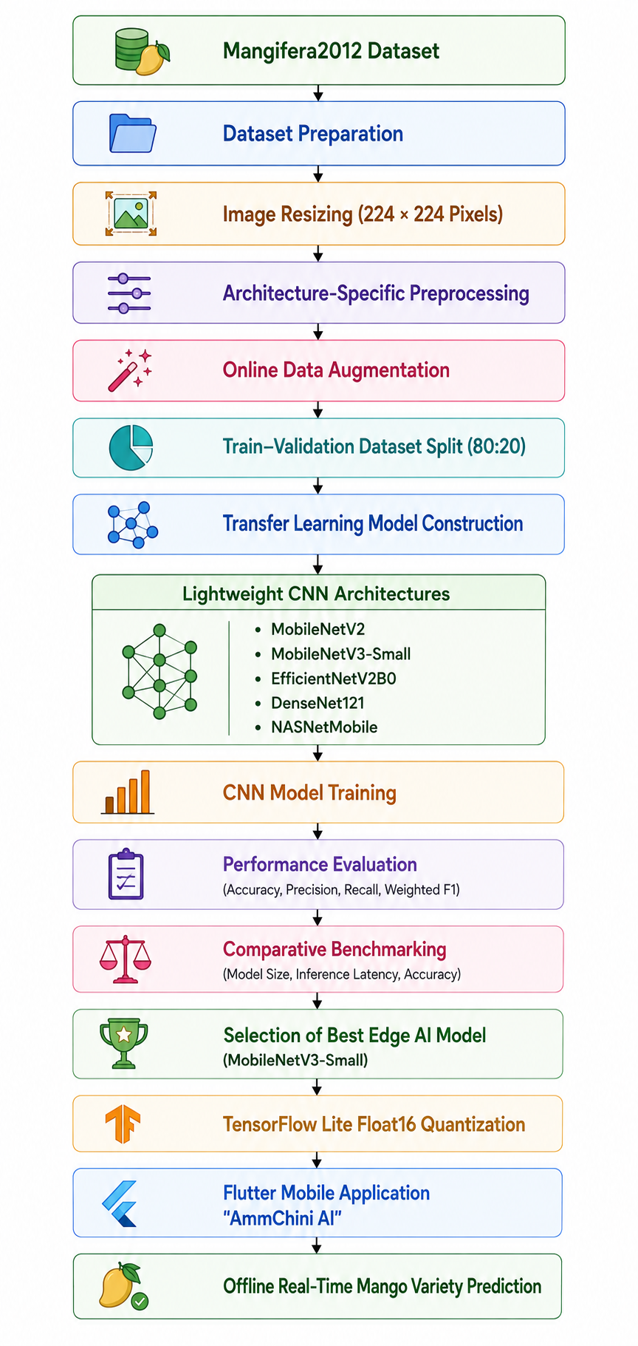
Figure 3.12 Proposed Research Methodology Flowchart

Description of Methodology Stages
The proposed methodology consists of the following sequential stages:
- Dataset Preparation: The Mangifera2012 dataset containing 2,012 images of ten indigenous Bangladeshi mango varieties is organized for supervised learning.
- Image Preprocessing: All images are resized to 224 × 224 pixels and processed using architecture-specific preprocessing functions to maintain compatibility with ImageNet-pretrained CNN models.
- Data Augmentation: Online augmentation techniques—including rotation, translation, shear transformation, zooming, and horizontal flipping—are applied to improve model generalization and reduce overfitting.
- Transfer Learning: Five pretrained CNN architectures (MobileNetV2, MobileNetV3-Small, EfficientNetV2B0, DenseNet121, and NASNetMobile) are fine-tuned using a common classification head while keeping the convolutional backbone frozen during the initial training stage.
- Performance Evaluation: Each model is evaluated using classification accuracy, precision, recall, weighted F1-score, confusion matrices, and classification reports.
- Comparative Benchmarking: Beyond predictive performance, deployment-oriented metrics such as model size and average inference latency are measured to identify the most suitable architecture for Edge AI deployment.
- Model Optimization: The selected MobileNetV3-Small model is converted to TensorFlow Lite (TFLite) format and optimized using Float16 post-training quantization, reducing storage requirements while maintaining classification performance.
- Mobile Deployment: The optimized TFLite model is integrated into the Flutter-based AmmChini AI application, enabling fully offline and real-time classification of indigenous Bangladeshi mango varieties on Android smartphones.

Importance of the Proposed Methodology
The proposed methodology extends beyond conventional deep learning workflows by combining comparative model benchmarking, deployment-aware optimization, and mobile application development within a single unified framework. This end-to-end approach ensures that the final system is not only accurate but also practical for deployment in resource-constrained agricultural environments. By emphasizing computational efficiency alongside predictive performance, the methodology effectively bridges the gap between laboratory-scale computer vision research and real-world precision agriculture applications.

3.5.1 Operational Workflow
The operational data flow begins when the user launches the AmmChini AI mobile application and selects an image for classification. The application allows users to either capture a new photograph using the smartphone camera or choose an existing image from the device gallery. Once an image is selected, it undergoes a sequence of preprocessing operations before being supplied to the TensorFlow Lite inference engine.
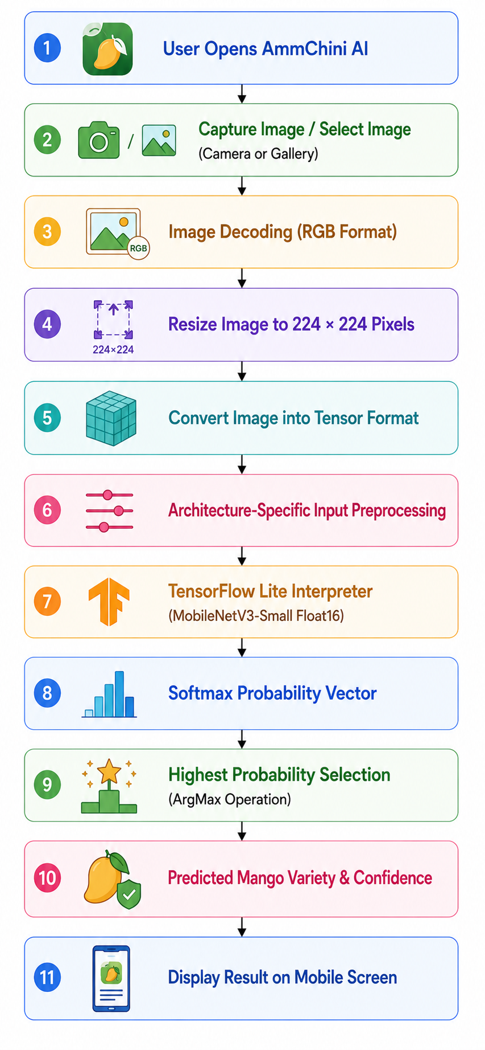
The complete operational workflow is illustrated in Figure 3.13.

3.5.6 Result Visualization
After inference is completed, the application presents the prediction results through a user-friendly graphical interface.
The output includes:
- Predicted mango variety.
- Classification confidence score.
- Captured image preview.
Because all computations are performed locally, the prediction appears almost instantly, providing a seamless user experience suitable for practical agricultural applications.

Table 3.7 Operational Stages of the Edge AI Inference Pipeline
Stage | Operation | Purpose
1 | Image Acquisition | Capture or select mango image
2 | Image Decoding | Convert image into RGB format
3 | Image Resizing | Resize image to 224 × 224 pixels
4 | Input Preprocessing | Apply MobileNetV3-specific preprocessing
5 | Tensor Conversion | Generate input tensor for inference
6 | TensorFlow Lite Inference | Execute MobileNetV3-Small model locally
7 | Softmax Prediction | Compute probability of each mango variety
8 | Result Visualization | Display predicted class and confidence score

